|  |
| --- |
| **Baruch College Campus High School *College News* March 2017** |

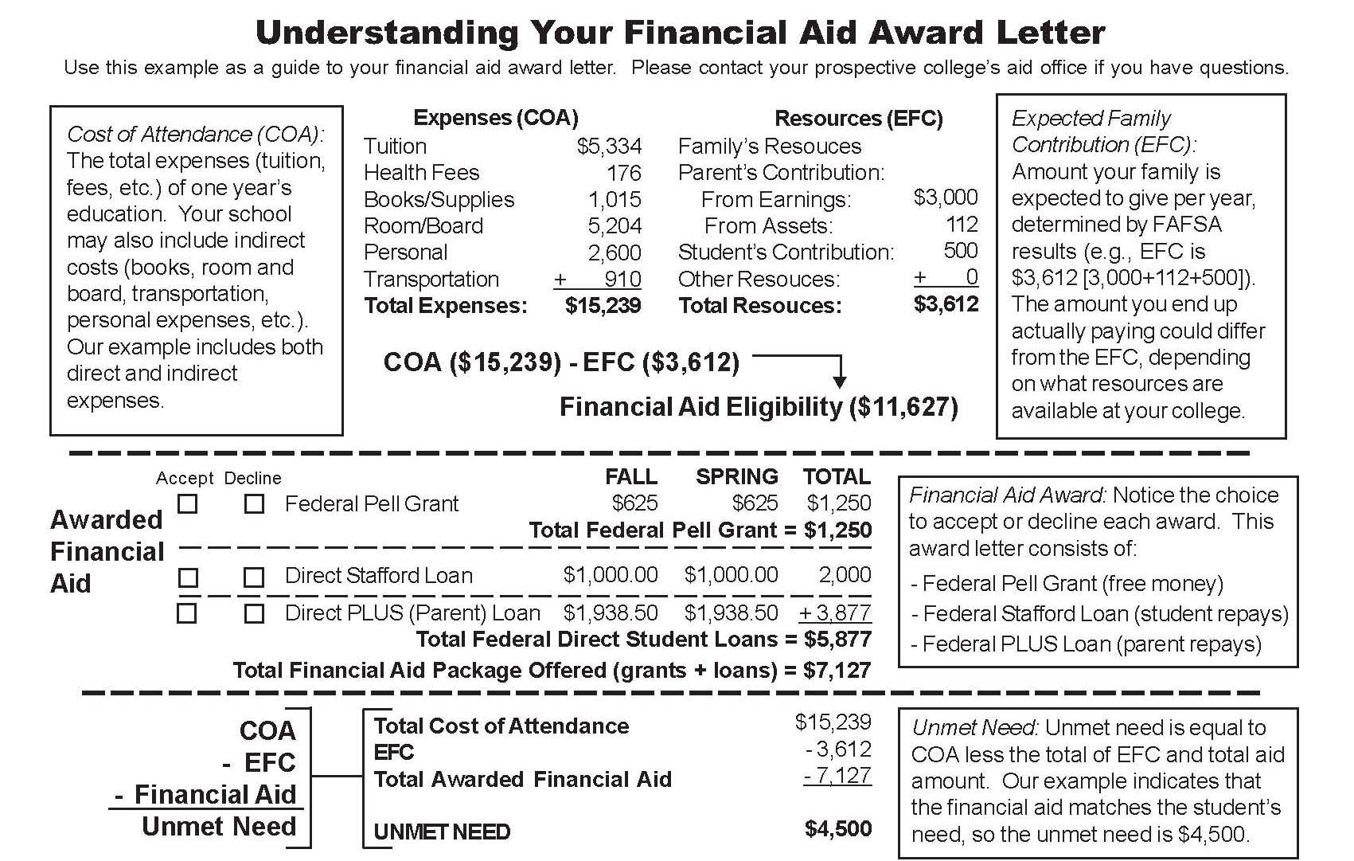

**FINANCIAL AID ETIQUETTE: DO’s**

* **Do compare financial aid with same “class” colleges.**
* **Do compare the same types of aid.**
* **Do be realistic in your aid expectations.**
* **Do identify why the college is awarding you aid.**

**\*IMPORTANT FINANCIAL AID INFO\***

**- Note your Data Release Number**

**(DRN).**Your DRN is the four-digit number located at the bottom left hand corner of your Student Aid Report (SAR). You will need it to apply for aid to any school you did not originally

list on your FAFSA.

**- Check if your SAR has been selected for verification.**If there is an asterisk (\*) after your Expected Family Contribution (EFC), it means your SAR has been selected for verification (one third of all SARS are selected).  Your prospective college will compare your SAR with documents, including tax returns, to verify your financial aid status.  If you are asked for verification, submit the information requested to your prospective college’s financial aid office ASAP!!  
  
**FINANCIAL AID ETIQUETTE: DON’Ts**

* **Don’t present aid demands as an ultimatum.**
* **Don’t accept a verbal offer for possible later aid.**
* **Don’t be impressed with additional loans as aid substitutes.**
* **Don’t turn down an offer until you have another one in writing.**
* **Don’t act arrogant in presenting aid already offered.**

**Financial Aid Package Review**

* 
* Do you have a financial aid package that you a do not understand?
* Are you unsure of what to accept?
* The College Office is always willing to assist you with these questions and more. On **Friday, April 1st** you can bring in your financial aid packages and we will assist you with any questions.

**Do you need a credit card?**



**PROS:**

* They can make expensive emergencies, such as a car breakdown, easier to handle.
* Making your monthly payments on time can help you establish good credit for purchases that you will make later in life.

**CONS:**

* If you cannot pay off your monthly bills on time, you will end up paying more for your purchases in the long run.
* You might be tempted to spend more money than your budget may allow.
* Avoid bankruptcy at all costs!! Bankruptcy stays on your credit report for 10 years!

**TIPS TO CONTROL CREDIT USE:**

* Select a card that does not charge an annual fee.
* Look for low annual percentage rates (APR).  The higher the interest, the more you will have to pay later.
* Ask about late payments, charging over your limit, and maintaining you balance.
* Have only ONE card with a low credit limit. A card with only $500 or $1,000 will help control your spending.
* **Shred and crosscut documents such as old bank statements, old credit cards, and pre-approved credit card offers.**
* **Make sure you receive new credit or bank cards in a timely manner.**
* **Don’t post personal information on blogging, instant messaging, and community websites.**
* **Password protect all accounts with made-up words and change them frequently. Use a combination of letters and numbers.**
* **Memorize your social security number (SSN) and passwords so they don’t need to be written down.**
* **Never give SSN, credit card or bank numbers to an unsolicited e-mailer, caller, even from parties that look legitimate (ex: bank or credit card company).**
* **Order your free credit report three times per year.  Visit annualcreditreport.com or call 877-322-8228 for more information.**
* **Do not use your SSN as an ID number.  Also, do not include SSN on your driver’s license or school ID.**
* **Notify your credit card company if you are missing a statement in the mail. It might have been stolen.**
* **Do not store bank or credit card account numbers on your computer**

**What To Do If You’re an ID Theft Victim:**

**-Contact your bank and credit card issuers**

**-File a report with your local law enforcement**

**-File a report with the Federal Trade Commission at** [www.consumer.gov/idtheft](http://www.consumer.gov/idtheft)

**-Notify the Social Security Administration** [www.ssa.gov](http://www.ssa.gov/) **if SSN was compromised**

**IMPORTANT SPRING PLANNING**



* + Request and receive forms for housing, health insurance, financial aid, etc.
  + Pursue student loan options if necessary.
  + Notify colleges of any private scholarship awards you might receive.
  + Advise your prospective college of any change in your contact information.
* 

|  |  |
| --- | --- |
| You must update your college decisions on your Naviance account by going to the **College tab** and then to ‘**Colleges I’m Applying to tab’.** By clicking on the pencil icon [edit](https://connection.naviance.com/family-connection/colleges/application/edit) you can then update the results of the colleges you applied to. |  |

If you are waited listed to a school that is you first choice school, you should come to the College Office to fill out a wait listed form.

.

**Other sites to check out:**   
www.students.gov  
www.fastweb.com  
[www.petersons.com](http://www.petersons.com/)   
[www.salliemaefund.org](http://www.salliemaefund.org/)   
[www.princetonreview.com/scholarships.aspx](http://www.princetonreview.com/scholarships.aspx)   
[www.brokescholar.com](http://www.brokescholar.com/)   
[www.studentscholarshipsearch.com](http://www.studentscholarshipsearch.com/)   
[www.internationalscholarships.com/index.php](http://www.internationalscholarships.com/index.php)   
<http://www.collegeanswer.com/>

**Summer’s Around the Corner- What’s your plan?**

Summer before college is a great time to earn some cash, gain great experiences, and secure an internship in a field you may be interested!

**All opportunities are posted on the new college office website.**

Internships, Research, Pre-College programs <http://bcchscollege.weebly.com/summer-opportunities.html>

Volunteer Opportunities

<http://bcchscollege.weebly.com/community-service.html>

**PHONE APPS TO FIND YOUR WAY TO AND THROUGH COLLEGE!**

* *For Planning a College Budget*= College Abacus or Mint
* *For Identifying a major that Supports Career=* What’s Your Road?, Career Connect, College Connect, Fast Forward, CollegeGo
* *For Identifying Obstacles to Program Completion=* WOOP, I’m First, Grad Guru, MyCoach
* *For Connecting to a Supportive Community*=What’s Your Road?, I’m First, Career Connect, Transfer Bootcamp, Grad Guru, MyCoach
* *For Meeting an Advisor*=Grad Guru, MyCoach, Logrado
* *For Resubmitting FAFSA by March 1 each Year*=FAFSA Community
* *For Connecting to Professionals in Chosen Career*=What’s Your Road?, Career Connect
* Find out more at: collegeappmap.org

https://wa01.bcc.cuny.edu/cunyfirst/img/cuny/cuny-logo.png

**Preparing for CUNY Placement exam**CUNY works hard to make sure each incoming student will succeed and thrive in classes which are appropriate for their needs and academic abilities by administering of the CUNY Assessment Tests. These placement exams help us determine if incoming students should directly enroll in credit-bearing courses, or take non-credit courses in reading, writing, mathematics, or ESL prior to more credit-bearing classes. We encourage incoming freshmen to prepare deliberately before taking any of these tests and have provided the following resources (which are also [online](http://nyc.us3.list-manage.com/track/click?u=164ccf4f94fa76018c7aaafed&id=13e1cb759d&e=9d079990ec" \t "_blank)) to help with the test preparation:

* a guide for the [CUNY Assessment Test in Reading](http://nyc.us3.list-manage1.com/track/click?u=164ccf4f94fa76018c7aaafed&id=06b6f3697f&e=9d079990ec" \t "_blank)
* a guide for the [CUNY Assessment Test in Writing](http://nyc.us3.list-manage.com/track/click?u=164ccf4f94fa76018c7aaafed&id=71bbf7dac0&e=9d079990ec" \t "_blank), and
* a guide for the [CUNY Assessment Test in Mathematics](http://nyc.us3.list-manage.com/track/click?u=164ccf4f94fa76018c7aaafed&id=db931ac04d&e=9d079990ec" \t "_blank)

If you completed the CUNY math test and were placed in College Calculus, you do not have to take this test again. You should contact the CUNY testing site that you were assigned and inform them that you did take the CUNY math test.