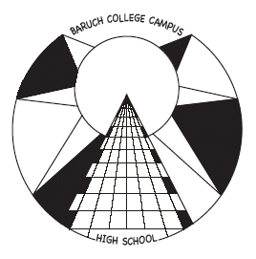
Baruch College Campus High School

College News

FOR JUNIORS

Dear Juniors,

This year is a year of quite a few changes regarding applying to college. These changes include the PSAT, SAT and financial aid. Below you will find information that will apprise you of the changes. Please take note of these changes and write in your calendar those dates that apply to you. There is also information regarding test prep for the SAT and ACT exam, which will be offered at our school. We hope that you read this carefully and use it as a tool to prepare you for the college process.

The College Office

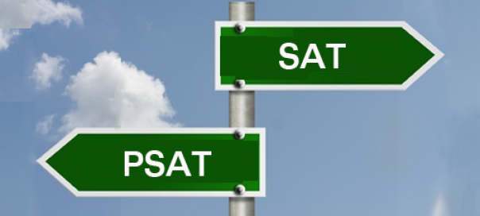
CHANGE 1.
This year the NYC DOE has replaced the administration of the PSAT (Practice SAT) in the fall of junior year with the administration of an actual SAT at BCCHS in the spring of junior year (April 5th).
In order to facilitate our students’ ability to take a practice SAT, we have engaged Kaplan to administer a FREE practice SAT for juniors only on Election Day, November 8th. We HIGHLY recommend that All juniors should take advantage of this opportunity! To register for the SAT practice test, students should use this link:
Link to Practice Test Registration: https://kaplan.formstack.com/forms/baruch_2016
Please remember to do so by the Registration Deadline: Sunday October 23rd, 2016
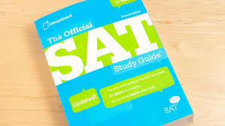
To help you prepare for the SAT exam our school will offer SAT preparation classes at BCCHS. They will take place after school on Mondays with practice tests in midtown Manhattan on Saturdays. Full price is $599 and financial aid is available for fee waiver candidates. These prep classes will begin in February and more information will be forthcoming.
CHANGE 2.
Next year for the first time the College Board will be offering the SAT August 26, 2017. Please take note of this as it could affect your summer plans.
We also suggest that students consider taking an ACT practice test. You can do so either at a prep company test center or at home. You should make sure that you the practice test “under test conditions.”
If, after taking the ACT practice test in the fall, you find that you prefer it, and/or score better than on the practice SAT, then we also suggest that you register for the April 8th ACT. You need do register and pay for it online: www.act.org (fee waivers available for eligible students in the college office).
We will also offer an ACT preparation class at BCCHS, if we have enough students registered for this class. It will be offered in March to prepare for the April exam. You will receive further information regarding this class.
After seeing your results of one or both of these spring tests, we suggest that you take another prep test class over the summer and register over the summer for the test that is the right fit for you either the SAT or ACT.
***Fee waivers are only available (for eligible students) for two SAT’s and two ACT’s in total.

Recommended SAT/ACT Test Schedule for juniors:
Students are expected to take two SATs or ACTs. Optimally, the first is taken in April of junior year (this year, the DOE will pay for it and it will happen on a school day at BCCHS). The second SAT (or ACT), for which students will need to register online and pay, should be taken by OCTOBER of senior year. This gives students time to advance academically in junior year, and if their first results need improvement, the time to improve them. It also enables students applying to highly competitive schools to take the SAT II subject tests that may be required by individual colleges in May, June or November.
To read more detailed information, go to: www.collegeboard.org for the SAT and
ACT www.act.org for the ACT. Colleges view both tests equally!

CHANGE 3.

FINANCIAL AID

This year there have been changes in the deadline date for FAFSA. It is important for you to be aware of the changes for when you prepare to apply next year. The deadline will be in October of your senior year. We will follow up with you on

FINANCIAL AID NIGHT
We will have a presentation of how to complete the FAFSA. If you want to get to be ahead of the game, you are welcome to attend the meeting, which will be on Monday, October 17th at 6:00pm. Both students and parents are welcome.

SAT Vs. the ACT Kaplan Presentaion
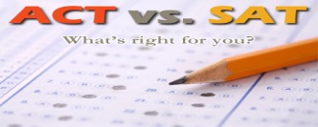
BCCHS will have a presentation by Kaplan on the SAT Vs. the ACT. This will take place at BCCHS on: Thursday, November 10th at 6:00pm. The event is for both juniors and parents/guardians

.CHANGE 4.
College Representative Visits
Every fall College Representatives come to visit our school. It is a great opportunity to find out about a college. These meeting have been for seniors, but we will open up these meetings to juniors who have a free at the time of the visit. You should not miss a class to attend these meetings. Please check the College Office bulletin board to sign up for the visits and to determine the locations. The listing will be updated , so check the listing regularly.

College Representative Visit Schedule
Date | College | Time | Room
9/19 | Boston University | 2:00 | TBA
9/23 | Rutgers University | 12:30 | TBA
9/26 | Pace University | 8:30 | TBA
9/26 | Univ. of Bridgeport | 10:00 | TBA
9/27 | Penn State | 10:06 | TBA
9/27 | Hobart William Smith | 11:00 | TBA
9/28 | Mt. Holyoke | 11:45 | TBA
9/29 | Colby College | 8:30 | TBA
9/30 | St. Francis College | 12:30 | TBA
10/5 | SUNY Oswego | 11:45 | TBA
10/6 | Wellesley College | 9:15 | TBA
10/6 | SUNY New Paltz | 12:30 | TBA
10/7 | St. Joseph’s | 11:40 | TBA
10/11 | Hunter College | 11:40 | TBA
10/17 | U Penn | 11:40 | TBA
10/19 | Clark University | 10:00 | TBA
10/19 | Stony Brook | 11:40 | TBA
10/20 | Hampshire College | 9:15 | TBA
10/21 | SUNY Albany | 8:30 | TBA
10/24 | Univ. of Conneticut | 8:30 | TBA
10/25 | Albany Coll. of Pharm | 8:30 | TBA
10/26 | Johnson and Wales | 12:30 | TBA
10/28 | U of Illinois | 10:00 | TBA

Upcoming College Fairs!

SUNY College Fair
September 25, 2016 12:30 pm
Armory Track & Field Center
216 Washington Ave, New York, NY 10032
www.suny.edu/studentevents

NACAC Performing and Visual Arts College Fair
Tuesday, October 19^{h}. 2015
Javits Center-644 W. 34th St., 6:00-9:00pm
www.nacacnet.org/pvastudent

Big Apple College Fair
October 22st, 2016
Javits Center – 655 W. 34th St., 1:00 – 4:00

STEM College & Career Fair

Saturday October 29, 2016 1-4 pm

Columbia University- Lerner Hall

www.nacacnet.org/STEMfairs

